SCHOOLWIDE/SCHOOL IMPROVEMENT PLAN TEMPLATE
School Name: Eastside High School |  |  | District Name: Newton County School System
Principal Name: Jeff Cher |  |  | School Year: 2019-2020
School Mailing Address: 10245 Eagle Dr. Covington, Georgia 30014
Telephone: 770-784-2920
District Title I Director/Coordinator Name: Dr. Shelia Thomas
District Title I Director/Coordinator Mailing Address: P.O. Box 1469 2109 Newton Dr. NE Covington, GA 30014
Email Address: thomas.shelia@newton.k12.ga.us
Telephone: 770-787-1330
ESEA WAIVER ACCOUNTABILITY STATUS
(Check all boxes that apply and provide additional information if requested.)
Comprehensive Support School ☐ |  | Targeted Support School ☐
Title I Alert School ☐

Revision Date: July 10, 2019 | Revision Date: 8/14/2019 |  |  | Revision Date:

DISTRICT STRATEGIC GOALS
Strategic Goal Area I: Student achievement and success
- Performance Objective A: Increase student mastery of standards
- Performance Objective B: Increase opportunities for students to demonstrate success beyond test scores
- Performance Objective C: Increase graduation rate
- Strategic Goal Area II: High-quality workforce
- Performance Objective A: Recruit a high-quality workforce
- Performance Objective B: Increase capacity of staff to deliver and support high-quality instruction
- Performance Objective C: Retain high-quality personnel by cultivating and supporting staff
- Strategic Goal Area III: Culture. Climate, & Communication
- Performance Objective A: Provide an equitable and inclusive learning environment
- Performance Objective B: Provide opportunities for two-way communication with all stakeholders
- Performance Objective C: Ensure strong community partnerships
• Strategic Goal Area IV: Organizational and operational effectiveness
- Performance Objective A: Ensure a systemic culture of safety
- Performance Objective B: Provide high-quality operational and instructional supports
- Performance Objective C: Utilize professional learning communities to improve performance
- Performance Objective D: Utilize performance management strategies aligned to the strategic plan

Planning Committee Members:

NAME | MEMBER’S SIGNATURE | POSITION/ROLE
Jeff Cher |  | Principal
Gloria Griffith |  | Assistant Principal
Phillip Davidson |  | Assistant Principal
Bart Buff |  | Assistant Principal
Jahmar Tate |  | Guidance Counselor
Keya Clay |  | Special Education Department Chairperson
Michael Gerald |  | Physical Education Department Chairperson
Michael Poor |  | Mathematics Department Chairperson
Betsy Proffit |  | Science Department Chairperson
Heather Hawk |  | Social Studies Department Chairperson
Alan Fowler |  | Fine Arts Department Chair
Heather Mathews |  | ELA Department Chairperson
Beth Bryan |  | Media Specialist
Monique Mitchell |  | Instructional Coach
Trina Nickson |  | EPIC Coordinator
Randy Norman |  | Technology Teacher Leader
Alison Anderon |  | CTAE Teacher
Tione Turner |  | Graduation Coach

American Lit EOC
All Students | 2016 |  |  | 2017 |  | 2018 | 2019
Level 4 | 9 |  |  | 14 |  | 15 | 7
Level 3 | 34 |  |  | 40 |  | 45 | 52
Level 2 | 39 |  |  | 35 |  | 28 | 32
Level 1 | 18 |  |  | 11 |  | 13 | 8
Black | 2016 |  |  | 2017 |  | 2018 | 2019
Level 4 | 1 |  |  | 6 |  | 3 | 3
Level 3 | 15 |  |  | 22 |  | 34 | 38
Level 2 | 48 |  |  | 49 |  | 38 | 45
Level 1 | 36 |  |  | 23 |  | 26 | 15
Hispanic | 2016 |  |  | 2017 |  | 2018 | 2019
Level 4 | 12 |  |  | 5 |  | 8 | 0
Level 3 | 29 |  |  | 47 |  | 42 | 45
Level 2 | 47 |  |  | 42 |  | 42 | 25
Level 1 | 12 |  |  | 5 |  | 8 | 30
White | 2016 |  |  | 2017 |  | 2018 | 2019
Level 4 | 14 |  |  | 21 |  | 22 | 9
Level 3 | 46 |  |  | 50 |  | 52 | 60
Level 2 | 33 |  |  | 25 |  | 20 | 28
Level 1 | 7 |  |  | 4 |  | 6 | 5
SWD | 2016 |  |  | 2017 |  | 2018 | 2019
Level 4 | 0 |  |  | 3 |  | 6 | 6
Level 3 | 5 |  |  | 6 |  | 3 | 22
Level 2 | 27 |  |  | 30 |  | 29 | 50
Level 1 | 68 |  |  | 61 |  | 64 | 25
ED | 2016 |  |  | 2017 |  | 2018 | 2019
Level 4 |  |  |  | 6 |  | 6 | 4
Level 3 |  |  |  | 33 |  | 32 | 39
Level 2 |  |  |  | 46 |  | 41 | 45
Level 1 |  |  |  | 15 |  | 21 | 12
Summary of EOC data: Data analysis of the 2019 11th Grade American Literature and Composition EOC reveals that 33% of our students were at a level 2 (developing) and 9% at level 1 (beginning). At the time of the test 47% of our students performed below grade level in reading and vocabulary. When looking at writing data, 36% of our students scored a 0-2 in idea development, organization, and coherence, 4% scored a 0-1 in language and conventions, and 57% scored a 0-2 on narrative writing.

Algebra I EOC
All Students |  | 2016 | 2017 |  | 2018 | 2019
Level 4 |  | 6 | 1 |  | 3 | 3
Level 3 |  | 28 | 25 |  | 21 | 22
Level 2 |  | 35 | 39 |  | 45 | 44
Level 1 |  | 31 | 35 |  | 31 | 31
Black |  | 2016 | 2017 |  | 2018 | 2019
Level 4 |  | 2 | 1 |  | 4 | 2
Level 3 |  | 20 | 16 |  | 13 | 20
Level 2 |  | 41 | 34 |  | 40 | 42
Level 1 |  | 38 | 49 |  | 42 | 37
Hispanic |  | 2016 | 2017 |  | 2018 | 2019
Level 4 |  | 0 | 4 |  | 0 | 8
Level 3 |  | 21 | 24 |  | 16 | 8
Level 2 |  | 36 | 40 |  | 32 | 50
Level 1 |  | 43 | 32 |  | 53 | 35
White |  | 2016 | 2017 |  | 2018 | 2019
Level 4 |  | 10 | 1 |  | 3 | 4
Level 3 |  | 34 | 32 |  | 27 | 25
Level 2 |  | 33 | 43 |  | 50 | 45
Level 1 |  | 23 | 25 |  | 21 | 27
SWD |  | 2016 | 2017 |  | 2018 | 2019
Level 4 |  | 4 | 2 |  | 2 | 0
Level 3 |  | 11 | 7 |  | 0 | 8
Level 2 |  | 15 | 23 |  | 23 | 26
Level 1 |  | 70 | 68 |  | 75 | 67
ED |  | 2016 | 2017 |  | 2018 | 2019
Level 4 |  |  | 1 |  | 3 | 2
Level 3 |  |  | 20 |  | 15 | 14
Level 2 |  |  | 38 |  | 40 | 45
Level 1 |  |  | 41 |  | 42 | 39
Summary of EOC data : 2018 Algebra 1 EOC reveals that 44% of our students were at a level 2 (developing) and 32% at level 1 (beginning). When assessing domain data, 68% of our students require remediation in Equations, 74% needing remediation in Expressions, 64% needing remediation in Functions, and 58 % needing remediation in Algebra Connections to Statistics and Probability.

US History EOC
All Students | 2016 | 2017 | 2018 | 2019
Level 4 | 13 | 19 | 18 | 8
Level 3 | 44 | 47 | 45 | 39
Level 2 | 32 | 23 | 26 | 34
Level 1 | 11 | 11 | 10 | 20
Black | 2016 | 2017 | 2018 | 2019
Level 4 | 3 | 9 | 7 | 8
Level 3 | 37 | 41 | 37 | 33
Level 2 | 39 | 28 | 36 | 39
Level 1 | 22 | 22 | 21 | 20
Hispanic | 2016 | 2017 | 2018 | 2019
Level 4 | 20 | 6 | 0 | 5
Level 3 | 33 | 56 | 73 | 42
Level 2 | 47 | 33 | 27 | 42
Level 1 | 0 | 6 | 0 | 11
White | 2016 | 2017 | 2018 | 2019
Level 4 | 20 | 27 | 28 | 19
Level 3 | 49 | 50 | 45 | 49
Level 2 | 26 | 19 | 22 | 26
Level 1 | 5 | 5 | 4 | 7
SWD | 2016 | 2017 | 2018 | 2019
Level 4 | 0 | 9 | 11 | 16
Level 3 | 15 | 11 | 11 | 23
Level 2 | 15 | 20 | 36 | 39
Level 1 | 70 | 60 | 42 | 23
ED | 2016 | 2017 | 2018 | 2019
Level 4 |  | 8 | 13 | 6
Level 3 |  | 46 | 40 | 41
Level 2 |  | 28 | 33 | 37
Level 1 |  | 18 | 14 | 15
Summary of data : Data analysis of the 2019 United States History EOC reveals that 11% of our students were at a level 1 (beginning), 30% were at a level 2 (developing), 44% were at a level 3 (proficient), and 15% were at a level 4 (distinguished). When looking closely at the data, 39% of students require remediation in “Colonization through the constitution,” 29% of students require remediation in “New Republic through Reconstruction,” 45% of students require remediation in “Industrialization, reform, & Imperialism,” 42% of students require remediation in “Establishment as a World Power,” and 41% of students require remediation in “Post WWII to the present.”

Geometry EOC
All Students | 2017 | 2018 | 2019
Level 4 | 16 | 9 | 14
Level 3 | 47 | 39 | 37
Level 2 | 26 | 36 | 28
Level 1 | 12 | 17 | 21
Black | 2017 | 2018 | 2019
Level 4 | 3 | 0 | 8
Level 3 | 38 | 24 | 29
Level 2 | 35 | 44 | 27
Level 1 | 25 | 32 | 37
Hispanic | 2017 | 2018 | 2019
Level 4 | 0 | 4 | 0
Level 3 | 54 | 40 | 28
Level 2 | 45 | 36 | 39
Level 1 | 0 | 20 | 33
White | 2017 | 2018 | 2019
Level 4 | 24 | 12 | 20
Level 3 | 50 | 45 | 43
Level 2 | 20 | 33 | 29
Level 1 | 7 | 10 | 9
SWD | 2017 | 2018 | 2019
Level 4 | 4 | 0 | 7
Level 3 | 15 | 15 | 7
Level 2 | 39 | 40 | 45
Level 1 | 42 | 46 | 41
ED | 2017 | 2018 | 2019
Level 4 | 4 | 4 | 8
Level 3 | 48 | 32 | 32
Level 2 | 31 | 44 | 32
Level 1 | 17 | 20 | 29
Summary of EOC data : 2018 Analytic Geometry EOC reveals that 28% of our students were at a level 2 (developing) and 21% at level 1 (beginning). When assessing domain data, 50% of our students require remediation in Congruence and Similarity, 45% needing remediation in Circles, 43% of our students are needing remediation in Equations and Measurement, 49 % needing remediation, and 47% needing remediation in Statistics and Probability.

Biology EOC
All Students | 2016 | 2017 | 2018 | 2019
Level 4 | 14 | 11 | 12 | 9
Level 3 | 38 | 37 | 43 | 41
Level 2 | 25 | 27 | 23 | 24
Level 1 | 23 | 25 | 22 | 26
Black | 2016 | 2017 | 2018 | 2019
Level 4 | 5 | 3 | 3 | 3
Level 3 | 28 | 22 | 37 | 25
Level 2 | 30 | 30 | 26 | 31
Level 1 | 37 | 46 | 34 | 40
Hispanic | 2016 | 2017 | 2018 | 2019
Level 4 | 0 | 4 | 10 | 3
Level 3 | 44 | 42 | 33 | 34
Level 2 | 31 | 27 | 24 | 31
Level 1 | 25 | 27 | 33 | 31
White | 2016 | 2017 | 2018 | 2019
Level 4 | 21 | 16 | 18 | 12
Level 3 | 46 | 44 | 47 | 54
Level 2 | 19 | 25 | 21 | 18
Level 1 | 15 | 15 | 14 | 16
SWD | 2016 | 2017 | 2018 | 2019
Level 4 | 0 | 5 | 2 | 3
Level 3 | 18 | 13 | 7 | 15
Level 2 | 14 | 15 | 17 | 19
Level 1 | 68 | 67 | 74 | 63
ED |  | 2017 | 2018 | 2019
Level 4 |  | 6 | 7 | 4
Level 3 |  | 30 | 39 | 33
Level 2 |  | 30 | 25 | 28
Level 1 |  | 34 | 30 | 35
Summary of EOC data: Analysis of the 2019 Biology EOC reveals that 26% of our students were at a level 1 (beginning learner) and 24% were at level 2 (developing). When looking at the biology data, 4% of our students scored in the remediate learning range in the cells portion, 38% scored in the remediate range in the genetics and heredity portion, 51% scored in the remediate range in the ecology portion, and 46% scored in the remediate range in the theory of evolution portion of the EOC, and 47% scored int he remediate range in organisms.

9th Grade Lit EOC
All Students | 2016 | 2017 | 2018 | 2019
Level 4 | 8 | 8 | 8 | 12
Level 3 | 42 | 54 | 52 | 53
Level 2 | 35 | 28 | 31 | 25
Level 1 | 15 | 10 | 9 | 9
Black | 2016 | 2017 | 2018 | 2019
Level 4 | 2 | 3 | 4 | 6
Level 3 | 29 | 40 | 39 | 39
Level 2 | 45 | 42 | 39 | 39
Level 1 | 24 | 16 | 18 | 15
Hispanic | 2016 | 2017 | 2018 | 2019
Level 4 | 0 | 8 | 0 | 11
Level 3 | 33 | 48 | 41 | 64
Level 2 | 40 | 20 | 53 | 21
Level 1 | 27 | 24 | 6 | 4
White | 2016 | 2017 | 2018 | 2019
Level 4 | 13 | 10 | 11 | 16
Level 3 | 52 | 62 | 61 | 62
Level 2 | 27 | 23 | 24 | 17
Level 1 | 8 | 5 | 4 | 6
SWD | 2016 | 2017 | 2018 | 2019
Level 4 | 0 | 2 | 0 | 2
Level 3 | 13 | 16 | 7 | 22
Level 2 | 27 | 43 | 44 | 39
Level 1 | 60 | 39 | 49 | 37
ED | 2016 | 2017 | 2018 | 2019
Level 4 |  | 2 | 6 | 6
Level 3 |  | 49 | 42 | 47
Level 2 |  | 37 | 40 | 32
Level 1 |  | 12 | 12 | 15
Summary of EOC data: Data analysis of the 2019 9th Grade Literature and Composition EOC reveals that 25% of our students were at a level 2 (developing) and 9% at level 1 (beginning). At the time of the test 33% of our students performed below grade level in reading and vocabulary. When looking at writing data, 60% of our students scored a 0-2 in idea development, organization, and coherence, 14% scored a 0-1 in language and conventions, and 58% scored a 0-2 on narrative writing.

Physical Science EOC
All Students | 2016 | 2017 | 2018 | 2019
Level 4 | 15 | 13 | 7 | 8
Level 3 | 41 | 44 | 42 | 39
Level 2 | 28 | 20 | 34 | 34
Level 1 | 17 | 23 | 17 | 20
Black | 2016 | 2017 | 2018 | 2019
Level 4 | 3 | 6 | 2 | 5
Level 3 | 28 | 33 | 35 | 29
Level 2 | 37 | 25 | 33 | 35
Level 1 | 33 | 37 | 31 | 32
Hispanic | 2016 | 2017 | 2018 | 2019
Level 4 | 17 | 6 | 5 | 6
Level 3 | 17 | 50 | 46 | 44
Level 2 | 44 | 13 | 32 | 28
Level 1 | 22 | 31 | 18 | 22
White | 2016 | 2017 | 2018 | 2019
Level 4 | 22 | 17 | 10 | 11
Level 3 | 51 | 51 | 43 | 44
Level 2 | 21 | 18 | 39 | 34
Level 1 | 7 | 14 | 9 | 11
SWD | 2016 | 2017 | 2018 | 2019
Level 4 | 5 | 5 | 4 | 3
Level 3 | 11 | 10 | 27 | 12
Level 2 | 26 | 20 | 24 | 35
Level 1 | 58 | 66 | 44 | 50
ED | 2016 | 2017 | 2018 | 2019
Level 4 |  | 7 | 7 | 7
Level 3 |  | 38 | 39 | 37
Level 2 |  | 23 | 25 | 32
Level 1 |  | 32 | 30 | 25
Summary of data: Analysis of the 2019 Physical Science EOC reveals that 20% of our students were at a level 1 (beginning learner) and 34% were at level 2 (developing). When looking at the Physical Science data, 48% of our students scored in the remediate learning range in the atomic and nuclear theory/periodic table portion, 41% scored in the remediate range in the chemical reactions and properties of matter portion, 42% scored in the remediate range in the energy, force, and motion portion, and 51% scored in the remediate range in the waves, electricity, and magnetism portion of the EOC.
Economics EOC
All Students | 2016 | 2017 | 2018 | 2019
Level 4 | 19 | 16 | 20 | 20
Level 3 | 44 | 51 | 41 | 41
Level 2 | 23 | 22 | 27 | 26
Level 1 | 14 | 11 | 11 | 14
Black | 2016 | 2017 | 2018 | 2019
Level 4 | 9 | 5 | 6 | 8
Level 3 | 37 | 47 | 31 | 37
Level 2 | 30 | 31 | 42 | 32
Level 1 | 25 | 17 | 20 | 23
Hispanic | 2016 | 2017 | 2018 | 2019
Level 4 | 18 | 6 | 12 | 20
Level 3 | 55 | 56 | 53 | 60
Level 2 | 18 | 25 | 24 | 10
Level 1 | 9 | 13 | 12 | 10
White | 2016 | 2017 | 2018 | 2019
Level 4 | 26 | 24 | 30 | 28
Level 3 | 48 | 55 | 45 | 41
Level 2 | 19 | 15 | 19 | 22
Level 1 | 8 | 7 | 6 | 8
SWD | 2016 | 2017 | 2018 | 2019
Level 4 | 10 | 0 | 0 | 10
Level 3 | 21 | 24 | 13 | 10
Level 2 | 24 | 35 | 38 | 26
Level 1 | 45 | 41 | 50 | 55
ED | 2016 | 2017 | 2018 | 2019
Level 4 |  | 7 | 6 | 10
Level 3 |  | 49 | 37 | 38
Level 2 |  | 29 | 39 | 30
Level 1 |  | 16 | 17 | 22
Summary of Data: Data analysis of the 2019 Economics EOC reveals that 14% of our students were at a level 1 (beginning), 26% were at a level 2 (developing), 41% were at a level 3 (proficient), and 20% were at a level 4 (distinguished). When looking closely at the data, 33% of students require remediation in “Fundamental Economic Concepts,” 32% of students require remediation in “Microeconomic Concepts,” 27% of students require remediation in “Macroeconomic Concepts,” 40% of students require remediation in “International Economics,” and 34% of students require remediation in “Personal Finance Economics.”

BEHAVIOR INCIDENTS BY ED
School Year | F&R Lunch | Total
18-19 | 1181 | 1704
17-18 | 1361 | 1893
16-17 | 1048 | 1623
BEHAVIOR INCIDENTS BY RACE
School Year | White | Black | Hispanic | Multi. | Total
18-19 | 589 | 1001 | 67 | 47 | 1704
17-18 | 589 | 1188 | 61 | 34 | 1893
16-17 | 597 | 946 | 41 | 34 | 1623

Parent Involvement Survey Data

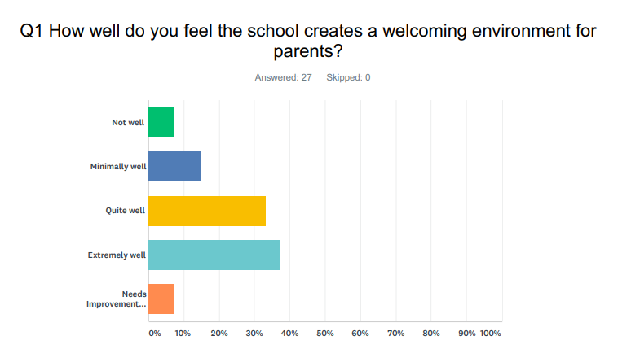
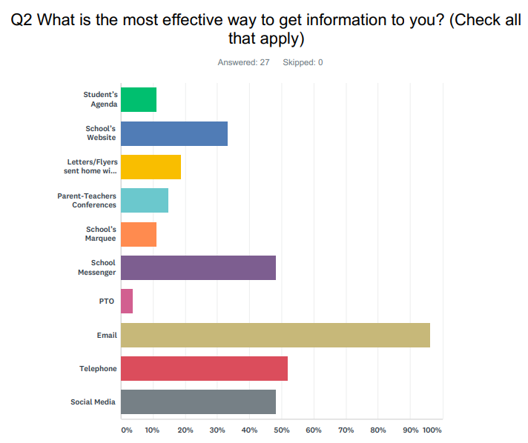

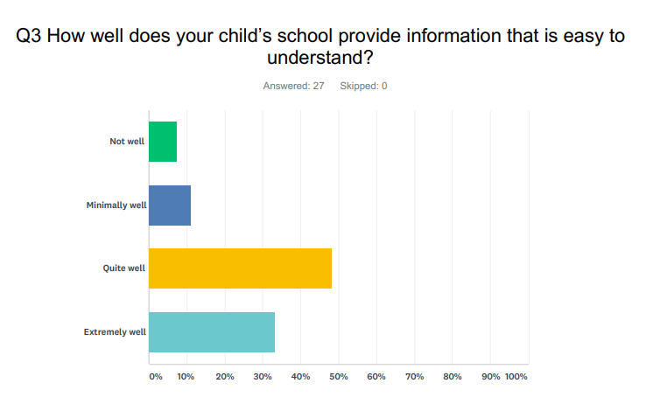

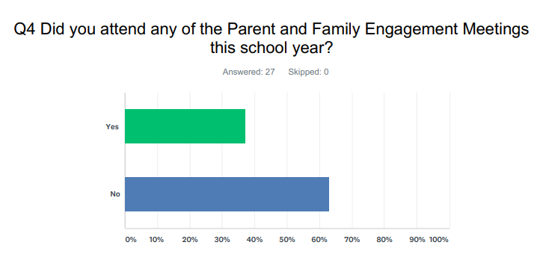

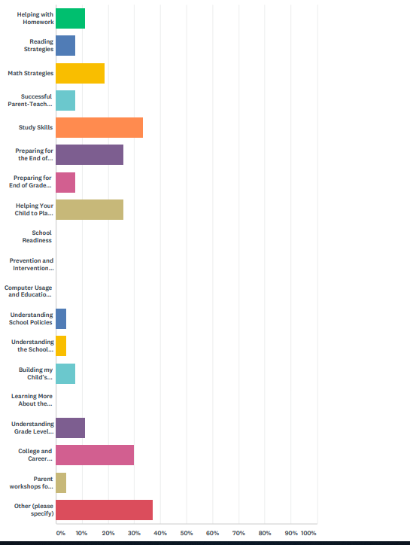
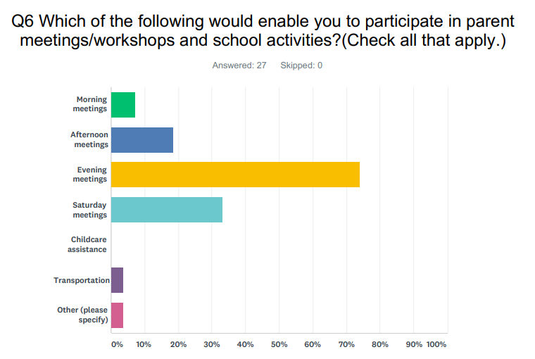

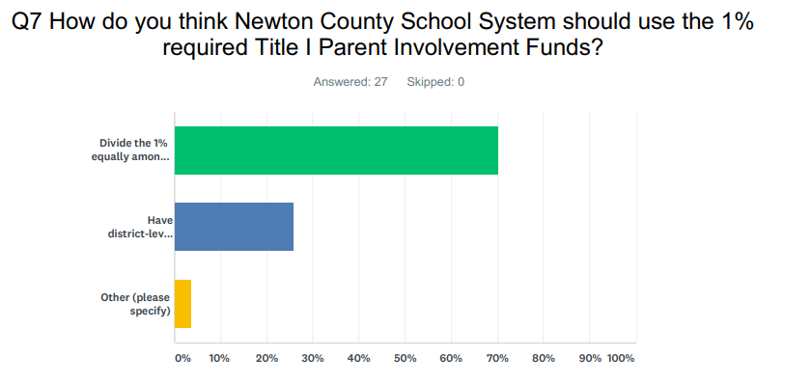
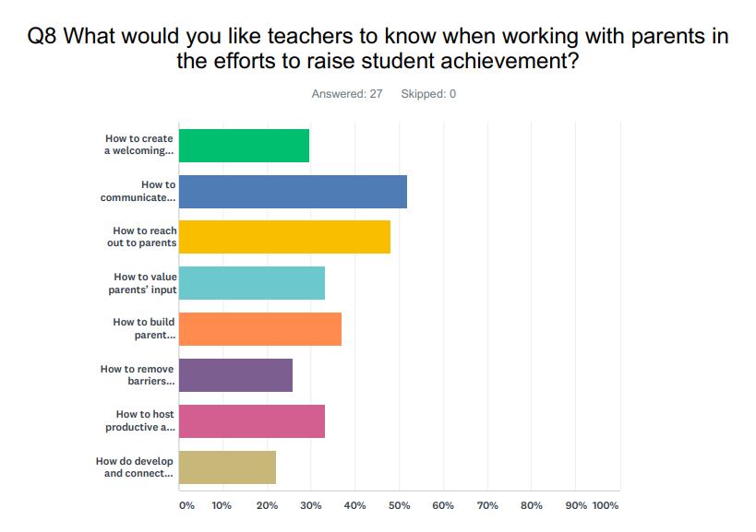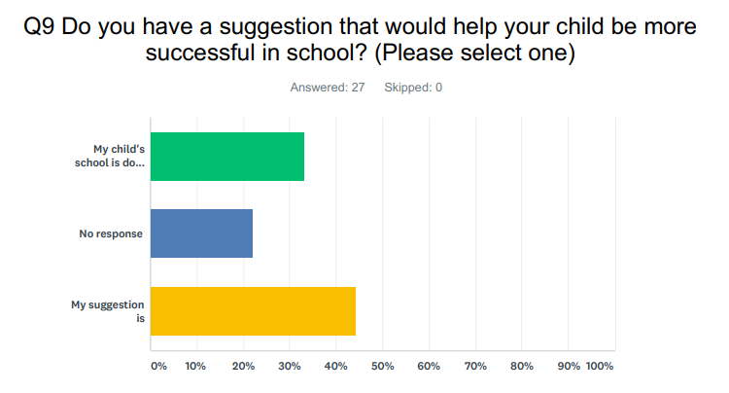

Summary of Data: Our Parent Survey shows that we need to address the number of parents who take the survey to gain a better sampling of the population to determine the needs of our parents. Our goal is to get at least 33% or more of our parent population to take the survey.

Why are students not performing well in Math?
ROOT CAUSE | HOW TO ADDRESS CONCERNS
Algebra 1: Based on 2018-2019 Ga Milestones scores, students across all subgroups performed lower under the algebra connections to the functions, expressions, and equations domains. | Instructional Coach to support teaching practices by instructional strategies and professional learning.
Geometry: Based on 2018-2019 Ga Milestones scores, students across all subgroups performed lower under the similarity and congruence and statistics and probability domains. | Provide access for teachers to attend conferences to support student achievement.
 | Technology through laptop carts, calculators, and document cameras to demonstrate strategies to support learning.
 | Utilize Professional Learning Communities to address the following: collaboration among content teachers, increase common planning among content teachers, and address concerns through data analysis.
 | Students lack appropriate background knowledge and skills
SMART Goal:
Algebra 1: To increase the percentage of Monitored Learning students by 3% in the domains of Equations, Expressions, and Functions

Geometry: To increase the percentage of Monitored Learning students by 3% in the domains of Similarity and Congruence and Statistics and Probability

Why are students not performing well in ELA/Reading?
ROOT CAUSE | HOW TO ADDRESS CONCERNS
Based on 2018-2019 Ga Milestones scores, 33% of our 9th grade students need remediation in reading and vocabulary and 47% of our 11th grade students need remediation in reading and vocabulary. | Instructional Coach to support teaching practices by instructional strategies and professional learning.
Based on 2018-2019 Ga Milestones scores, 60% of our 9th grade students and 36% of our 11th grade students scored below a 3 on the development/organization/coherence portion of the Extended Writing section. | Use technology through laptop carts and document cameras to demonstrate strategies to support learning.
Based on 2018-2019 Ga Milestones scores, 58% of our 9th graders and 57% of our 11th graders scored below a 3 on the Narrative Writing section. | Provide access for teachers to attend conferences to support student achievement.
 | Provide alternate text when available (i.e. graphic novel) for extended reading assignments.
SMART Goal: Students will show a 3% increase in their reading and vocabulary scores on the EOC, a 3% increase in the development/organization/coherence portion of the Extended Writing section of the EOC, as well as a 3% increase on the Narrative Writing section.

Why are students not performing well in Science?
ROOT CAUSE | HOW TO ADDRESS CONCERNS
Biology: Based on 2018-2019 Ga Milestones scores, performance of all our students across all subgroups are not performing well in the domain of Ecology. | Instructional Coach to support teaching practices by research based instructional strategies and professional learning.
Physical Science: Based on 2018-2019 Ga Milestones scores, performance of all our students across all subgroups are not performing well in the domains of Chemistry: Atomic and Nuclear Theory/Periodic Table with the lowest are being Physics: Waves, Electricity, and Magnetism. | Provide access for teachers to attend conferences to support student achievement.
 | Technology through laptop carts, calculators, and document cameras to demonstrate strategies to support learning.
 | Instructional focus period (ACADEX) to provide additional instructional support.
 | Utilize Professional Learning Communities to address the following: collaboration among content teachers, increase common planning among content teachers, and address concerns through data analysis.
SMART Goal:
Biology: To increase the percentage of Monitored Learning students by 3% in the domain of Ecology.

Physical Science: To increase the percentage of Monitored Learning students by 3% in the domains of Chemistry: Atomic and Nuclear Theory/Periodic Table and Physics: Waves, Electricity, and Magnetism.

Why are students not performing well in Social Studies?
ROOT CAUSE | HOW TO ADDRESS CONCERNS
Based on 2018-2019 the United States History Ga Milestones scores, all students performed lower on the domain related to "Colonization through the Constitution," relative to other domains. | Utilize Professional Learning Communities to address the following: collaboration among content teachers, increase common planning among content teachers, and address concerns through data analysis.
Based on 2017-2018 the Economics Ga Milestones scores, all students performed lower on the domain related to "International Economics," relative to other domains. | Utilize Professional Learning Communities to address the following: collaboration among content teachers, increase common planning among content teachers, and address concerns through data analysis.
SMART Goal:
United States History: To increase the percentage of Monitored Learning students by 3% in the domain of "Colonization through the Constitution."

Economics: To increase the percentage of Monitored Learning students by 3% in the domain of "International Economics."

Why are students not performing well in Behavior?
ROOT CAUSE | HOW TO ADDRESS CONCERNS
Based on 2018-2019 behavior data, behavior instances among black students and students that were economically disadvantaged are disproportionate to their populations. | Instructional Coach to support teaching practices by classroom management strategies and professional learning.
 | Provide access for teachers to attend conferences to support classroom management and student behavior.
 | New student orientation and behavior expectation meetings.
 | Provide access for teachers to attend conferences to support student behavior.
SMART Goal: To decrease the overall discipline incidents with all students for the 2019-2020 school year

2. Schoolwide Reform Strategies that: Sec. 1114(b)(7)(A)(i-iii)
2a.i School-wide reform strategies that the school will be implementing to address school needs, including a description of how such strategies will provide opportunities for all children, including each of the subgroups of students (economically disadvantage students, students from major racial and ethnic groups, children with disabilities and English learners [Sec 1111(c)(2)]) to meet the challenging State academic standards;

2a.ii School-wide reform strategies that the school will be implementing to address school needs, including a description of how such strategies will use methods and instructional strategies strengthen the academic program in the school, increase the amount and quality of learning time, and help provide an enriched and accelerated curriculum, which may include programs, activities, and courses necessary to provide a well-rounded education
MATH GOAL
Students will increase their math scores by 3% on the Georgia Milestones End of Course Assessments.
OVERARCHING MATH PROGRAM
EHS follows the Newton County School Systems Curriculum Maps and other resource materials to support the Math initiatives. EHS also uses the county level formative assessments to guide instructional decisions to ensure that all student meet the state’s academic achievement standards
Evidence-Based Action Steps: Describe the evidence-based action steps to be taken to achieve the goals.
Person(s) Responsible: Principal Instructional Coach Media Specialist, All Teachers
Intervention/Strategy/Practice  (If Title I Funded, a Logic Model is required.) |  | Timeline for Implementation | Funding Source | Evaluation Methods | Resources Needed
Implement personalize student learning in math and provide proven academic support through practice, immediate feedback, and built-in remediation to improve students’ performance. |  | August 2019- May 2020 | Local Funds | EOC  Growth Reports  Logic Model | USA Test Prep
Canvas is an online learning management systems that to simplifies teaching and learning by connecting all the digital tools for teachers. EHS teachers will upload math assignments and videos to assist with learning beyond the school day. |  | Ongoing for 2019-2020 school year | No Funding Source | Observations  Lesson Plans | Computers
Teachers help students develop a better understanding of mathematical concepts, use higher-level approaches to solving math problems, and score higher on performance measures. |  | Ongoing for 2019-2020 school year | Title I Part A | EOC  Lesson Plans | Graphing Calculators  Storage Bins
Supplemental Supports: What supplemental action steps will be implemented for these subgroups?
Economically Disadvantage | Foster And Homeless
We will provide additional support to students based on individual student needs via supplemental academic programs. | We will work with the Foster Care and Homeless Liaison will work with schools to support the goals of improving educational outcomes for homeless and foster care students
English Learners | Migrant
ELs will be served by an ESOL-endorsed teacher. Supplemental resources and materials will be purchased using Title III-LEP funds | ELs will be served by an ESOL-endorsed teacher. Supplemental resources and materials will be purchased using Title III-LEP funds
Race/Ethnicity/Minority | Students With Disabilities
We will provide additional support to students based on individual student needs via supplemental academic programs | We will provide additional support to students based on individual student needs via supplemental academic programs

ELA/READING GOAL
Students will increase their ELA/Reading scores by 3% on the Georgia Milestones End of Course Assessments.
OVERARCHING ELA PROGRAM
Eastside High School (EHS) follows the Newton County School Systems Curriculum Maps and SpringBoard resources and materials to support the ELA/Reading initiatives. EHS also uses the county level formative assessments to guide instructional decisions to ensure that all student meet the state’s academic achievement standards.
Evidence-Based Action Steps: Describe the evidence-based action steps to be taken to achieve the goals.
Person(s) Responsible: Principal Instructional Coach Media Specialist, All Teachers
Intervention/Strategy/Practice  (If Title I Funded, a Logic Model is required.) | Timeline for Implementation |  | Funding Source | Evaluation Methods | Resources Needed
Implement personalize student learning in ELA and provide proven academic support through practice, immediate feedback, and built-in remediation to improve students’ performance. | August 2019- May 2020 |  | Local Funds | EOC  Growth Reports  Logic Model | USA Test Prep
Canvas is an online learning management systems that to simplifies teaching and learning by connecting all the digital tools for teachers. EHS teachers will upload ELA assignments and videos to assist with learning beyond the school day. | August 2019- May 2020 |  | Local Funds | Observations  Lesson Plans | Computers
The ELA department developed Quizlets for grades 9-12 as a study tool that allows students to study ELA content via learning tools and games | August 2019- May 2020 |  | No Funds | Lesson Plans  Usage Reports  Observations | Computers
Supplemental Supports: What supplemental action steps will be implemented for these subgroups?
Economically Disadvantage |  | Foster And Homeless
We will provide additional support to students based on individual student needs via supplemental academic programs. |  | We will work with the Foster Care and Homeless Liaison will work with schools to support the goals of improving educational outcomes for homeless and foster care students
English Learners |  | Migrant
ELs will be served by an ESOL-endorsed teacher. Supplemental resources and materials will be purchased using Title III-LEP funds |  | ELs will be served by an ESOL-endorsed teacher. Supplemental resources and materials will be purchased using Title III-LEP funds
Race/Ethnicity/Minority |  | Students With Disabilities
We will provide additional support to students based on individual student needs via supplemental academic programs |  | We will provide additional support to students based on individual student needs via supplemental academic programs

SCIENCE GOAL
Students will increase their science scores by 1% on the Georgia Milestones End of Course Assessments.
OVERARCHING SCIENCE PROGRAM
EHS follows the Georgia Frameworks for Science. We also use the county level curriculum maps which identifies the vocabulary, standards, technology resources and formative assessments to meet the needs of all our students.

Evidence-Based Action Steps: Describe the evidence-based action steps to be taken to achieve the goals.
Person(s) Responsible: Principal Instructional Coach Media Specialist, All Teachers
Intervention/Strategy/Practice  (If Title I Funded, a Logic Model is required.) | Timeline for Implementation |  | Funding Source
Implement personalize student learning in Science and provide proven academic support through practice, immediate feedback, and built-in remediation to improve students’ performance. | August 2019- May 2020 |  | Local Funds | Growth Reports  EOC  Observation  Lesson Plans  Logic Model | USA Test Prep
Canvas is an online learning management systems that to simplifies teaching and learning by connecting all the digital tools for teachers. EHS teachers will upload Science assignments and videos to assist with learning beyond the school day. | August 2019- May 2020 |  | Local Funds | Observation  Lesson Plans | Computer
Supplemental Supports: What supplemental action steps will be implemented for these subgroups?
Economically Disadvantage |  | Foster And Homeless
We will provide additional support to students based on individual student needs via supplemental academic programs. |  | We will work with the Foster Care and Homeless Liaison will work with schools to support the goals of improving educational outcomes for homeless and foster care students
English Learners |  | Migrant
ELs will be served by an ESOL-endorsed teacher. Supplemental resources and materials will be purchased using Title III-LEP funds |  | ELs will be served by an ESOL-endorsed teacher. Supplemental resources and materials will be purchased using Title III-LEP funds
Race/Ethnicity/Minority |  | Students With Disabilities
We will provide additional support to students based on individual student needs via supplemental academic programs |  | We will provide additional support to students based on individual student needs via supplemental academic programs

SOCIAL STUDIES GOAL
Students will increase their social studies scores by 1% on the Georgia Milestones End of Course Assessments.
OVERARCHING SOCIAL STUDIES PROGRAM
EHS follows the Georgia Frameworks for Social Studies. We also use the county level curriculum maps which identifies the vocabulary, standards, technology resources and formative assessments to meet the needs of all our students.
Evidence-Based Action Steps: Describe the evidence-based action steps to be taken to achieve the goals.
Person(s) Responsible: Principal Instructional Coach Media Specialist, All Teachers
Intervention/Strategy/Practice  (If Title I Funded, a Logic Model is required.) | Timeline for Implementation |  | Funding Source | Evaluation Methods | Resources Needed
Implement personalize student learning in Social studies and provide proven academic support through practice, immediate feedback, and built-in remediation to improve students’ performance. | August 2019- May 2020 |  | Local Funds | Growth Reports  EOC  Observation  Lesson Plans  Logic Model | USA Test Prep
Canvas is an online learning management systems that to simplifies teaching and learning by connecting all the digital tools for teachers. EHS teachers will upload Social Studies assignments and videos to assist with learning beyond the school day.  Title I Logic Model: Yes ☐ No☒ | August 2019- May 2020 |  | Local Funds | Observations  Lesson Plans | Computer
Supplemental Supports: What supplemental action steps will be implemented for these subgroups?
Economically Disadvantage |  | Foster And Homeless
We will provide additional support to students based on individual student needs via supplemental academic programs. |  | We will work with the Foster Care and Homeless Liaison will work with schools to support the goals of improving educational outcomes for homeless and foster care students
English Learners |  | Migrant
ELs will be served by an ESOL-endorsed teacher. Supplemental resources and materials will be purchased using Title III-LEP funds |  | ELs will be served by an ESOL-endorsed teacher. Supplemental resources and materials will be purchased using Title III-LEP funds
Race/Ethnicity/Minority |  | Students With Disabilities
We will provide additional support to students based on individual student needs via supplemental academic programs |  | We will provide additional support to students based on individual student needs via supplemental academic programs

OTHER INSTRUCTIONAL METHODS
Use effective instructional methods that increase the quality and amount of learning time.
      - increase the amount and quality of learning time, such as providing and extended school year and before- or after-school and summer programs and opportunities, and help provide an enriched and accelerated curriculum
      - increase the amount and quality of learning time, such as class-size reduction teachers, supplemental teachers, paraprofessionals, etc.
Evidence-Based Action Steps: Describe the evidence-based action steps to be taken to achieve the goals.
Person(s) Responsible: Principal Instructional Coach Media Specialist, All Teachers
Intervention/Strategy/Practice  (If Title I Funded, a Logic Model is required.) | Timeline for Implementation | Funding Source | Evaluation Method | Resources Needed
Instructional Coach to support teaching practices by instructional strategies and professional learning. | August 2019-May 2020 | Title I, Part A | EOC  Logic Model  Coaching Log | Chart Paper  Ink  Sticky Notes  Highlighters  Laptop
21 Century Afterschool Program provides students with homework assistance in all content areas. | August 2019-May 2020 | ASAP | Parent Surveys  Meeting Evaluations
Credit Recovery use Pearson Connexus and Georgia Virtual School to help students at risk of failing a course, not graduating with their class, or not advancing to the | August 2019-May 2020 | Local Funds | Usage Reports  Growth Reports  Meeting Evaluations | Connexus
Eastside offers rigorous instruction throughout the school day. Many students struggle to maintain adequate progress towards graduation in a typical four-year span. To address the needs of all students, we offer students an ACADEX period where students will receive writing practice, specific remediation, credit-recovery, focused reading, support services, mentoring, and advisement. | August 2019-May 2020 | Local Funds | Usage Reports  Growth Reports  Meeting Evaluations | ACADEX
The ELA department will incorporate a Reading/Writing Support class for ninth graders that addresses below grade level abilities identified by Lexile scores. | August 2019- May 2020 | Local Funds | EOC  Lesson Plans | Coach Books  USA Test Prep  Canvas  Quizlet

PARENT AND FAMILY ENGAGEMENT PROGRAM
Evidence-Based Action Steps: Describe the evidence-based action steps to be taken to achieve the goals.
Person(s) Responsible: Principal Instructional Coach Media Specialist, All Teachers
Intervention/Strategy/Practice  (If Title I Funded, a Logic Model is required.) | Timeline for Implementation | Funding Source | Evaluation Methods | Resources Needed
Parent and Student Workshops are offered to build parent capacity by sharing research-based instructional strategies to help high school students to become college and career ready. | August 2019-May 2020 | Title I, Part A | Parent Survey  Meeting Evaluations  Parent Conferences  Sign-in Sheets | Paper  Copies  Translator  Light Snacks  Ink  Chart Paper  Pens  Highlighters  Calculators
Parents Still Make a Difference and Middle school Parent Pointers are research-based newsletters and tip sheets that provide practical, proven information for parents, on a comprehensive array of school success topics. The documents will be posted on our school’s website and located in our parent resource room and main office. | August 2019-May 2020 | District Funded | PICC  Screenshot | Parents Make a Difference
Parent Resource Room will be open to parents throughout the week and parent nights. The Parent Resource Room provides parents with resources for check-out that reinforces those skills that students may need to improve achievement. | August 2019-May 2020 | Title I, Part A | Check in/out System | Copy Paper  Ink
We will offer in-person and continuous support and training to teachers to assist teachers in building the capacity to work with parents as equal partners. | August 2019-May 2020 | Title I, Part A | Meeting Evaluation  Sign-In Sheets | PPT  Handouts/Articles  Compact/Policy
Grade-Level Parent and Family Meetings are held to inform and update parents and families on graduation requirements. | August 2019-May 2020 | No Funding Source | Meeting Evaluations  Sign-In Sheets | Copy Paper  Ink

PROFESSIONAL LEARNING
Evidence-Based Action Steps: Describe the evidence-based action steps to be taken to achieve the goals.
Person(s) Responsible: Principal Instructional Coach Media Specialist, All Teachers
Intervention/Strategy/Practice  (If Title I Funded, a Logic Model is required.) | Timeline for Implementation | Funding Source | Evaluation Methods |  | Resources Needed
Professional learning devoted to increasing frequency and effectiveness of communication with parents and how faculty and staff can contribute to increasing parental engagement | 2019-2020 | Title I Part A | Sign In Sheets  Meeting Evaluations  Logic Model |  | Copy Paper  Ppt  Ink  Handouts/Articles
Continued use of common planning time to facilitate effective professional learning communities | 2019-2020 | Local Funds | Sign In Sheets  Meeting Evaluations  Logic Model |  | Copy Paper  Ppt  Ink  Handouts/Articles
Increased content enrichment and development of a broader network of subject-specific resources through professional associations/conferences | 2019-2020 | Title I,  Part A | Sign In Sheets  Meeting Evaluations  Logic Model | Copy Paper  Ppt  Ink  Handouts/Articles
Utilize Professional Learning Communities to address the following: collaboration among content teachers, increase common planning among content teachers, and address concerns through data analysis. | 2019-2020 | Local Funds | Sign In Sheets  Meeting Evaluations  Logic Model | Copy Paper  Ppt  Ink  Handouts/Articles
New Teachers will participate in district funded BEST Teacher Program to work with a school based-mentor in efforts to assist with day to day routines in addition to provide job embedded professional learning that focuses on new teacher issues | 2019-2020 | Local Funds | Sign In Sheets  Meeting Evaluations  Logic Model | Copy Paper  Ppt  Ink  Handouts/Articles

TECHNOLOGY EQUIPMENT TO SUPPORT THE CORE CURRICULUM
Evidence-Based Action Steps: Describe the evidence-based action steps to be taken to achieve the goals.
Person(s) Responsible: Principal Instructional Coach Media Specialist, All Teachers, Technology Specialist
Intervention/Strategy/Practice  (If Title I Funded, a Logic Model is required.) | Timeline for Implementation | Funding Source | Evaluation Methods | Resources
Calculators will be used by teachers to demonstrate research-based strategies to support student learning in the areas of math and science. Access to calculators will assist students in learning math skills. Teachers will model solving math problems on the calculators and “scaffold” learning leading the students to work more accurately and independently in math. | August 2019-May 2020 | Title I, Part A | Lesson Plans  EOC  Observations | Graphing Calculators  Calculator Storage
Demonstrate researched-based strategies to support student learning in ELA/Reading and Math. Document cameras will engage the students in the learning process. Teachers will use cameras to display student work samples, ELA/Reading and Math exemplars, error analysis, and as a method to address multiple learning styles during ELA/Reading and Math instruction. | August 2019-May 2020 | Title I, Part A | Lesson Plans  EOC  Observations | Document Cameras
Support student learning in the areas of ELA/Reading and Math instruction. Access to laptops will assist students in learning math skills and ELA / Reading skills. The laptops will be used in grade-level specific efforts with students to build basic foundational skills and remediation skills through interactive learning. | August 2019-May 2020 | Title I, Part A | Lesson Plans  EOC  Observations | Chromebooks  Carts

STUDENT BEHAVIOR/ATTENDANCE
Evidence-Based Action Steps: Describe the evidence-based action steps to be taken to achieve the goals.
Person(s) Responsible: Principal Instructional Coach Media Specialist, All Teachers
Intervention/Strategy/Practice  (If Title I Funded, a Logic Model is required.) | Timeline for Implementation | Funding Source | Evaluation Methods | Resources Needed
Talon Talks | August 2019-May 2020 | No Funding | Teacher and Student Interview | No Resources

BUILDING FAMILY FRIENDLY SCHOOLS
In the section below, describe strategies to build family-friendly schools by providing a high quality customer service.
Front Office Staff:
Welcome each parent, student, and visitor with a smile and welcoming attitude.
Maintain a safe and clean school that enhances the school climate and learning environment.
Inform parents that a family resource section is available for community use.

Administrators:
Welcome each parent, student, and visitor with a smile and welcoming attitude.
Maintain a safe and clean school that enhances the school climate and learning environment.
Initiate and maintain proactive communication with parents, students, and families.
Meet with stakeholders to keep them updated on school improvement and school wide concerns.
Solicit school improvement feedback from stakeholders and partners in education

Classroom Teachers:
Welcome each parent, student, and visitor with a smile and welcoming attitude.
Maintain a safe and clean school that enhances the school climate and learning environment.
Counselors:
Welcome each parent, student, and visitor with a smile and welcoming attitude.
Maintain a safe and clean school that enhances the school climate and learning environment.
Maintain frequent communication and provide parents and families with performance updates.

Other Faculty/Staff:
Welcome each parent, student, and visitor with a smile and welcoming attitude.
Maintain a safe and clean school that enhances school climate and learning environment.

2a.iii School-wide reform strategies that the school will be implementing to address school needs, including a description of how such strategies will address the needs of all children in the school, but particularly the needs of those at risk of not meeting the challenging State academic standards, through activities which may include:
- counseling, school-based mental health programs, specialized instructional support services, mentoring services, and other strategies to improve students’ skills outside the academic subject areas
- Teacher-Student mentoring program to assist in the monitoring of academic progress and identify potential students
- Peer Mentoring program pairs upperclassmen with underclassmen to help students matriculate through high school with success.
- Sources of Strength is a Mental Health Awareness Program/Club designed to treat needs of the our student population
- preparation for and awareness of opportunities for postsecondary education and the workforce, which may include career and technical education programs and broadening secondary school students’ access to coursework to earn postsecondary credit while still in high school (such as Advanced Placement, International Baccalaureate, dual or concurrent enrollment, or early college high schools);
- College and Career Parent and Student Nights will provide students and parents with the knowledge, skills, and tools to help with success beyond high school.
- Advance Placement Classes will provide students the opportunity to take college-level courses while in high school.
- Newton County College and Career Academy enhance academic achievement and provide students with the knowledge and skills necessary to succeed in postsecondary education and the workforce.

- implementation of a schoolwide tiered model to prevent and address problem behavior, and early intervening services, coordinated with similar activities and services carried out under the Individuals with Disabilities Education Act (20 U.S.C. 1400 et seq.);
New students (not those coming from NCSS middle schools) who transfer/enroll at the start of the year will be welcomed by an administrator.
- This could be achieved in a group (Talon Talk) session during which the administrator will help orientate the new students to our school. During this session, students will learn about Eastside, our expectations, and be given the opportunity to speak with the administrator in a positive, proactive setting.
- An attempt will be made to include the parents in this endeavor.

As new students transfer into Eastside during the school year, they will be welcomed by an administrator.
- The administrator will help introduce and familiarize the new student to the school. During this session the student will learn about Eastside, our expectations, and be given the opportunity to speak with the administrator in a positive, proactive setting.
- An attempt will be made to include the parents in this introductory meeting.

A list of Eastside expectations and understandings will be generated and available to share with students who enter Eastside after the first day of school.

A further analysis of the numbers of students classified as either dropouts/withdrawals will be undertaken.
- professional development and other activities for teachers, paraprofessionals, and other school personnel to improve instruction and use of data from academic assessments, and to recruit and retain effective teachers, particularly in high need subjects
- We have included teachers, principals, paraprofessionals and, if appropriate, pupil services personnel, parents, and other staff in our staff development that addresses the root causes of our identified needs. Eastside High School currently relies on professional learning communities to address most professional learning needs.

Root Cause | Professional Learning to Address Root Cause
Not assigning students according to Lexile rigor level | District Mathematics Instructional Coach will organize and facilitate vertical curriculum planning for secondary mathematics and English teacher leaders
Students lack strategies to comprehend reading in all courses | Receiving training from district ELA Instructional Coach on strategies that target reading comprehension
Students not equipped with the test taking skills | Teacher will model appropriate test taking strategies for students
Students lacking background knowledge and foundational skills | Train teachers on how to access Lexile data located in Illuminate

- We have included teachers in professional development activities regarding the use of academic assessments, to enable them to provide information on, and to improve, the achievement of individual students and the overall instructional program in the following ways.

Professional Learning Activity | Year Offered | Participants | Location
Infinite Campus Training | 2013-2020 | School Wide | On Site/County Level
Safari Montage Training | 2013-2020 | School Wide | On Site/County Level
Co Teaching Strategies | 2013-2020 | School Wide | On Site/County Level
Parent Communication | 2013-2020 | School Wide | On Site/County Level
Technology Integration | 2013-2020 | School Wide | On Site/County Level
“Understanding Backwards Designs” | 2013-2020 | School Wide | On Site
Differentiated Instructed | 2013-2020 | School Wide | On Site/County Level/Griffin RESA
Researched Based Instructional Strategies | 2013-2020 | School Wide | On Site/County Level/Griffin RESA
Canvas | 2016-2020 | School Wide | On Site/County Level

- We have devoted sufficient resources to carry out effectively the professional development activities recruit and retain effective teachers, particularly in high need subjects in the following ways.
Teachers of the same content area work together to routinely analyze their content standards and develop common assessments (both formative and summative) that adequately demonstrate a student’s mastery of a standard. As common assessments are administered, teachers routinely meet in Common Planning to analyze data, design plans for remediation, and develop lesson plans that appropriately address the strengths and weaknesses that are recognized through these frequent checks for understanding.

- strategies for assisting preschool children in the transition from early childhood education
Response: We have also included transition plans for students entering middle school or high school and for students entering from private schools including students entering our school throughout the school year.

During the spring of the 8th grade students’ school year, the counseling department will meet with the middle school counselors, teachers, students and parents. The high school develops a registration form and the form is presented to the middle school staff, current 8th grade students, and their families. A meeting is held with the 8th grade teachers to discuss the registration form. Middle school teachers make academic recommendations and families review their recommendations. A presentation is made to the 8th grade students during the school day at the middle school by the high school staff. A presentation is made to 8th grade families during the evening at the high school. CTAE and other elective teachers hold an elective fair during the meeting. Students and their families have an opportunity to learn more about electives and rank order elective choices on their registration form. A high school special education teacher is included in the IEP meeting held for current 8th grade students at the middle school.

Eagle Flight School
Eagle Flight School is a day-long event held in the summer for all rising 9th grade students to assist the students in transitioning to high school. The event is coordinated by administration and current 9th grade teachers. Several staff members and students assist in the program presentation. High school expectations, graduation requirements, attendance policy, discipline expectations, and other items are discussed throughout the day with the students. The students are given campus tours led by other students.

Open House
Open House is held by the school for all students. Schedules are provided by the counseling department and families and students are welcome to tour the school and visit classrooms. Grade level meetings are held with every grade and hosted by the principal, other administrators, and counselors. Topics included in the student groups include expectations, high school success, graduation completion and other topics.

High School 101
The counseling department offers a High School 101 group presented to all 9th grade acadex classes. The delivery model is by peer leaders and senior students are trained to present topics on study skills, success in high school, learning modalities, and test taking skills.

- Schoolwide Plan Development: Sec. 1114(b)(1-5)
- is developed during a 1-year period, unless— the school is operating a schoolwide program on the day before the date of the enactment of the Every Student Succeeds Act, in which case such school may continue to operate such program, but shall develop amendments to its existing plan during the first year of assistance after that date to reflect the provisions of this section;
Response: When preparing to convert from a Targeted Assistance to a School-wide Title I Program, Eastside High School engaged in a year-long process, which began with a review of school-wide student achievement data, including the 2012 CCRPI report, 2013 EOCT results, and other data sources. The planning process was facilitated by an outside Title I consultant and a team of administrators, teachers and staff worked together to develop the Title I Plan. The plan is a fluid document and continues to be reviewed and updated annually.

- is developed with the involvement of parents and other members of the community to be served and individuals who will carry out such plan, including teachers, principals, other school leaders, paraprofessionals present in the school, administrators (including administrators of programs described in other parts of this title), the local educational agency, to the extent feasible, tribes and tribal organizations present in the community, and, if appropriate, specialized instructional support personnel, technical assistance providers, school staff, if the plan relates to a secondary school, students, and other individuals determined by the school
Response: The Eastside High School-wide Title I Plan was developed by a broad spectrum of Eastside’s educational community. These members include:
The Leadership Team
Administration
Counseling Department
Special Education Department Chair
CTAE Department Chair
Media Specialist
Math Department Chair
Science Department Chair
Social Studies Department Chair
English Language Arts Department Chair
Title I Instructional Coach
District Director of Federal Programs
Graduation Coach
Title I Consultant
A draft of the Title I School-wide Plan will be presented to the School Council in August 2019. Additionally, copies will be made available for parents, students, and the community on the school website and in the school’s front office. The school messenger and social media feeds will be used to announce the locations of the draft Title I School-wide Plan. A draft of the Title I School-wide Plan will be presented to a diverse group of students, including selected members of: Student Government and the Student Advisory Council. All substantive feedback received from these stakeholders will be used to make modifications to the plan where indicated.
- remains in effect for the duration of the school’s participation under this part, except that the plan and its implementation shall be regularly monitored and revised as necessary based on student needs to ensure that all students are provided opportunities to meet the challenging State academic standards;
Response: We will monitor our Title I Plan regularly by reviewing data to and making adjustments to prioritize our needs with input from all stakeholders. The Title I Plan will be posted on our school’s website to give all stakeholders the opportunity to review and give input. Copies of the Title I plan will be made available at the request of any stakeholder. All stakeholders will be invited to our annual Title I input meeting where they may give feedback on the Title I Plan.
- is available to the local educational agency, parents, and the public, and the information contained in such plan shall be in an understandable and uniform format and, to the extent practicable, provided in a language that the parents can understand;
Response: Eastside High School will make the Title I Plan available to the LEA, parents, and the public through a variety of communication avenues. An electronic copy of the plan will be posted on the school’s web page. We will post links to the Title I Plan on the EHS Twitter and Facebook pages. We will email a link to all parents through our SchoolMessenger system. Hard copies of the plan will be available in the school’s front office and media center. Additional copies will be filed with the NCSS Office of Federal Programs and the NCSS Parent Resource Center. Any parent or community member may request a physical copy of the Title I Plan through the principal.

- ESSA Requirements to Include in your Schoolwide Plan
- Define how your interventions are evidence-based; or other effective strategies to improve student achievement. Sec. 1111(d)(B)

Response: We are using evidence-based or other effective strategies to improve student achievement through the use of logic models.
See Appendix for Software Logic Model ( All software programs must have a separate logic model)
See Appendix for Instructional Coach Logic Model
See Appendix for Title I Tutoring Program Logic Model
See Appendix for Title I Class Size Reduction Logic Model
See Appendix for Title I Supplemental Teacher Logic Model
See Appendix for Title I Paraprofessional Logic Model
See Appendix for Professional Learning
See Appendix for Behavior Logic Model
See Appendix for Building Parent Capacity Logic Model
See Appendix for Building Staff Capacity Logic Model
See Appendix for Parent Survey
- Describe how the school will implement effective parent and family engagement strategies under section 1116; Sec. 1112(b)(7)
All students participating in the Title I, Part A program, and their families will be encouraged and invited to fully participate in all parent and family engagement opportunities. Eastside High School will provide full opportunity for the participation of parents and family members by…

Linked to Learning Meetings
- We will provide assistance to parents regarding understanding the state standards, state and local assessments, provide materials and training to help parents work with their children to improve their achievement (including education about the harms of copyright piracy), as appropriate, to foster parent and family engagement using primary and secondary methods.
Annual Title I Parent Orientation
- Invite all parents in multiple ways to our annual parent orientation meeting, at a convenient time, to inform parents about the school’s Title I program, the nature of the Title I program, the parents’ requirements and the school parent and family engagement policy, the schoolwide plan, and the school-parent compact.
Accessibility
- We will share information related to school and parent programs, meetings, and other activities to the parents of participating children (including parents and family members who have limited English proficiency, parents and family members with disabilities, and parents and family members of migratory children) in a format and, to the extent practicable, in a language the parents can understand.
Annual Parent Input Meeting
- Jointly developing with parents of participating children a school-parent compact that outlines how parents, the entire school staff, and students will share the responsibility for improved student academic achievement and the means by conducting an annual parent input meeting and by providing feedback forms on our school’s website, in our front office or parent resource room.
Coordinating Programs
- Coordinating and integrating parental involvement programs and activities with other Federal, State, and local programs, including public preschool programs, and conducting other activities, such as parent resource centers, that encourage and support parents to fully participating in the education of their children
Flexible Meeting Times
- We will offer flexible number of meetings, such as meetings in the morning or evening, and may provide, with funds provided under Title I, transportation, childcare, or home visits.
Other Reasonable Support
- Providing such other reasonable support for parental involvement activities, as parents may request.

- If a middle or high school, describe how the school will implement strategies to facilitate effective transitions for students from middle grades to high school and from high school to postsecondary education including, if applicable—
- through coordination with institutions of higher education, employers, and other local partners; and
Response: We will plan activities for assisting preschool children in the transition from early childhood programs. We have also included transition plans for students entering middle school or high school and for students entering from private schools including students entering our school throughout the school year.

During the spring of the 8th grade students’ school year, the counseling department will meet with the middle school counselors, teachers, students and parents. The high school develops a registration form and the form is presented to the middle school staff, current 8th grade students, and their families. A meeting is held with the 8th grade teachers to discuss the registration form. Middle school teachers make academic recommendations and families review their recommendations. A presentation is made to the 8th grade students during the school day at the middle school by the high school staff. A presentation is made to 8th grade families during the evening at the high school. CTAE and other elective teachers hold an elective fair during the meeting. Students and their families have an opportunity to learn more about electives and rank order elective choices on their registration form. A high school special education teacher is included in the IEP meeting held for current 8th grade students at the middle school.

Eagle Flight School
Eagle Flight School is a day-long event held in the summer for all rising 9th grade students to assist the students in transitioning to high school. The event is coordinated by administration and current 9th grade teachers. Several staff members and students assist in the program presentation. High school expectations, graduation requirements, attendance policy, discipline expectations, and other items are discussed throughout the day with the students. The students are given campus tours led by other students.

Open House
Open House is held by the school for all students. Schedules are provided by the counseling department and families and students are welcome to tour the school and visit classrooms. Grade level meetings are held with every grade and hosted by the principal, other administrators, and counselors. Topics included in the student groups include expectations, high school success, graduation completion and other topics.

High School 1
The counseling department offers a High School 101 group presented to all 9th grade acadex classes. The delivery model is by peer leaders and senior students are trained to present topics on study skills, success in high school, learning modalities, and test taking skills.

Parent Meetings
- through increased student access to early college high school or dual or concurrent enrollment opportunities, or career counseling to identify student interests and skills; Sec. 1112(b)(10)
Response: The counseling department offers a variety of parent meetings for students and their families throughout the school year. These meetings include a grade level meeting for 9th, 10th, 11th and 12th grade students and families. Meetings cover topics such as PSAT, SAT, ACT, and GHSGT/EOCT interpretation of results, presentations on dual enrollment, and AP programs. Representatives from external post-secondary organizations are present to discuss the dual enrollment program, youth apprenticeship program, and military options.

Individual Advisement and Bridge Law
The counselors will provide individual advisement to every student. Advisement includes course selection and career planning. College admissions and post-secondary training is discussed. Opportunities through the Newton College and Career Academy will be presented to students through advisement, informational booths, and an open house at the academy. The counselors will provide opportunities for the students in each grade to meet the Bridge Law requirements in a computer lab to further their knowledge of post-secondary options, setting transition goals, and understanding their interests as related to careers.

12th Grade Transition Program
During the senior year, there are many opportunities for the students and their families to learn more about opportunities and the transition after high school. Every student completes an “After High School Transition Plan” using their gacollege411 personal account. This is monitored by the school counselor for completion. Senior students are involved in an annual “Georgia Apply to College Week” event. This event includes activities such as the following: one day of computer access to complete college applications, visits by current college students and college personal, military information, and other events to encourage post-secondary options. Career information is shared throughout the school year via the announcements. Individual advisement is held with every senior by the counseling department to discuss individual plans. Senior seminars and senior parent meetings are held twice a year. The ASVAB is offered to all senior students. A small group for first time college students is conducted by the counseling

TITLE I INSTRUCTIONAL COACH
MODEL | RESPONSES
SMART Goal: | Increase student achievement on the EOC assessments in all areas by 3% by the end of the 2019-2020 school year as measured by the GMAS.
Intervention/Strategy/Practice: | Instructional Coach
Is there an ESSA Rating in place for this software? If so, what is it? | Strong Evidence ☐  Moderate Evidence☐  Minimal Evidence☐  No ESSA Rating Exist: ☒
Current Research Available that demonstrated rationale that suggests it may work:
Response:
Instructional Coaching
By: Lucy Steiner, Julie Kowal
http://www.readingrockets.org/article/instructional-coaching
Three Steps to Great Coaching
http://cabooseit.s3.amazonaws.com/makes_sense_strategies/3-steps-to-great-coaching.pdf
Marzano, R. J., Pickering, D., & Pollock, J. E. (2001). Classroom instruction that works: Research-based strategies for increasing student achievement. Alexandria, Va: Association for Supervision and Curriculum Development.
Intervention Population: | Instructional coaches work with all of our teachers with a variety of instructional-related topics.
Person Responsible: | Principal, Instructional Coaches
Implementation Plan of Action:
Response:
- Instructional coaches meet once weekly to lead grade level and content area PLCs, focusing on topics including instructional strategies, instructional planning, and data analysis.
- Instructional Coaches complete walk-throughs to assess instructional needs.
- Instructional Coaches also work with teachers on an individual basis to provide support. They provide individual professional learning and instructional modeling as needed.
How will the success be measured? What is the school’s theory of change for this intervention? | Administrator participation in (and evaluation of) PLCs led by instructional coaches will be one way the success of this position is measured. CCRPI scores will be an additional measure of the successful impact of this position.
What are the outcomes or milestones that will evaluate success? | Beginning of the Year: 2019 CCRPI data. Spring 2019 EOC data. These data sources will provide baseline data and will assist in planning professional learning throughout the year.
 | End of Year: Spring 2020 EOC data will be the primary sources used to determine effectiveness of the schoolwide instructional program. Correlation of these data sources to professional learning which occurred during the year will be reviewed as indicators of success of this position.
Progress Monitoring Dates: | Beginning of the Year: September 2019
 | Mid-Year: December 2019
 | End of Year: May 2020
Evidence-Based Evaluation | Due May 15, 2020
NCSS Feedback:
PROFESSIONAL LEARNING
MODEL | RESPONSES
SMART Goal: | To increase achievement in all subject areas by 3% by as measured by EOC by the end of the 2019-2020 school year
Intervention/Strategy/Practice: | Professional Learning
Current Research Available that demonstrated rationale that suggests it may work:
Marzano, R. J., Pickering, D., & Pollock, J. E. (2001). Classroom instruction that works: Research-based strategies for increasing student achievement. Alexandria, Va: Association for Supervision and Curriculum Development.

Five Phases of Professional Development :North Central Regional Educational Laboratory
http://www.readingrockets.org/article/five-phases-professional-development

Is there an ESSA Rating in place for this software? If so, what is it? | Strong Evidence ☐  Moderate Evidence☐  Minimal Evidence☐  No ESSA Rating Exist: ☒
Intervention Population: | Administration and certified teachers
Person Responsible: | Instructional Coaches, Administration
Implementation Plan of Action:
- Gather information through walkthroughs, observations, classroom data, and surveys to determine professional learning needs
- Determine which staff will benefit from the professional learning session
- Identify objectives and measurable evidence for building teacher capacity and student achievement.
- Specify additional learning opportunities and follow-up sessions to support implementation; plan for differentiated opportunities when necessary
- Identify and allocate resources to properly support professional learning
- Determine how professional learning will be evaluated
How will the success be measured? What is the school’s theory of change for this intervention? | - Sign in sheets from each Professional Learning activity  - Walkthrough Forms/Data  - Evaluation Forms
What are the outcomes or milestones that will evaluate success? | Beginning of Year: 2019 CCRPI data. Spring 2019 EOC data. These data sources will provide baseline data and will assist in planning professional learning throughout the year. Fifty percent of the teachers will implement strategies demonstrated in Professional Learning based on the 1st nine weeks Instructional Coach walkthroughs.
 | End of Year: To increase achievement in all subject areas by 3% by as measured by EOC by the end of the 2019-2020 school year
Progress Monitoring Dates: | Beginning of the Year: September 2019
 | Mid-Year: December 2019
 | End of Year: May 2020
Evidence-Based Evaluation | Due May 15, 2020
NCSS Feedback:

TITLE I PARENT ENGAGEMENT PROGRAM
MODEL | RESPONSES
SMART Goal: | To increase achievement in all subject areas by 3% by as measured by EOC by the end of the 2019-2020 school year
Intervention/Strategy/Practice: | Building Parent Capacity using Primary and Secondary Methods
Current Research Available that demonstrated rationale that suggests it may work:
Parent involvement strategies in urban middle and high schools in the Northeast and Islands Region https://ies.ed.gov/ncee/edlabs/regions/northeast/pdf/REL_2009069.pdf

Partners Education in A Dual Capacity-Building Framework for Family–School Partnerships https://www2.ed.gov/documents/family-community/partners-education.pdf
Is there an ESSA Rating in place for this software? If so, what is it? | Strong Evidence ☐  Moderate Evidence☐  Minimal Evidence☐  No ESSA Rating Exist: ☒
Intervention Population: | ☐K-5 ☐6-8 ☒9-12
Person Responsible: | Principal, Instructional Coach, Title I Parent Contact, Classroom Teachers
Implementation Plan of Action:
- Convene an annual parent orientation that informs parents about the Title I Program, the parents’ requirements, the school parent and family engagement policy, the schoolwide plan, and the school-parent compact.

- Provide parents opportunities to acquire necessary information, knowledge, and skills to support their children’s education at home and at school by implementing purposely-designed parent and family engagement opportunities that impact student achievement. .

- Review grade-level content area data and determine the skills/focus areas to strengthen school-improvement goals. Use the parent and family engagement planning forms to develop workshops that shares strategies and activities linked to the skills/focus areas in the efforts to build the capacity of the parents to complete the strategies/activities with their child effectively.

- Provide continuous communication to parents via / flyers / handouts / weekly folders/ brochures/emails / text messages / social media posts / website / parent portal or newsletter that shares links to video / tip sheets / that promotes effective school-parent partnerships.

- Host schoolwide parent-teacher conference days to share student progress at school, share academic and/or behavioral strategies and activities to propel students towards academic success.

- Inform and invite parents to our Parent Resource Room that provide parents and families with a variety of materials and resources to help support specific academic needs.

- Convene an annual parent input meeting to gather feedback on theTitle I Program, school and LEA parent and family engagement policies, the schoolwide plan, and the school-parent compact, building staff capacity, 1% parent budget, and the CLIP.
How will the success be measured? What is the school’s theory of change for this intervention? | We will use the feedback gathered from parent meeting evaluations, stakeholder meetings, and the parent surveys to evaluate the effectiveness of our Parent and Family Engagement Program.  We theorize that parents will become, supporters, encouragers, monitors, advocates, decision makers, and collaborators in the efforts to increase student achievement.
What are the outcomes or milestones that will evaluate success? | Higher grades and test scores, high school attendance, greater likelihood of graduating from high school, better chance of postsecondary enrollment, fewer discipline issues,
Evidence-Based Evaluation (Due May 22, 2020)

TITLE I PARENT ENGAGEMENT PROGRAM
MODEL |  | RESPONSES
SMART Goal: |  | To provide four or more opportunities to build staff capacity to work with parents as equal partners by the end of the 2019-2020 school year.
Intervention/Strategy/Practice: |  | Building Staff Capacity using Primary and Secondary Methods
Current Research Available that demonstrated rationale that suggests it may work:
Parent involvement strategies in urban middle and high schools in the Northeast and Islands Region https://ies.ed.gov/ncee/edlabs/regions/northeast/pdf/REL_2009069.pdf

Partners Education in A Dual Capacity-Building Framework for Family–School Partnerships https://www2.ed.gov/documents/family-community/partners-education.pdf

Is there an ESSA Rating in place for this software? If so, what is it? |  | Strong Evidence ☐  Moderate Evidence☐  Minimal Evidence☐  No ESSA Rating Exist: ☒
Intervention Population: |  | ☐K-5 ☐ 6-8 ☒9-12
Person Responsible: |  | Principal, Instructional Coach, Title I Parent Contact, Classroom Teachers
Implementation Plan of Action:
Primary Method  In-Person Faculty Meeting | 1st Nine Weeks |  | Due by August 31 of each school year |  | Powerful Partnerships:  Staff Parent and Family Engagement Orientation
*Secondary Method  Handouts, Tip Sheets, Videos | 2nd Nine Weeks |  | Due by the end of the 2nd nine weeks (December 20, 2019) |  | Optional tools to address topics identified with the assistance of parents.
Primary Method  In-Person Faculty Meeting | 3rd Nine Weeks |  | Due by January 31 of each school year |  | Powerful Partnerships:  Building Powerful Partnerships: School Parent Compacts
*Secondary Method  Handouts, Tip Sheets, Videos | 4th Nine Weeks |  | Due by the end of the 4th nine weeks  (May 8, 2020) |  | Optional tools to address topics identified with the assistance of parents.
How will the success be measured? What is the school’s theory of change for this intervention? |  |  |  | We will measure the success of by having each participating complete an evaluation form after the building staff capacity professional learning sessions. We will also collect feedback after each secondary method on how we can use the strategies shared to enhance our parent and family engagement program.  We theorize that our faculty and staff will provide high-quality customer service, honor and recognize families’ funds of knowledge, connect family engagement to student learning, and create a welcoming and an inviting school culture
What are the outcomes or milestones that will evaluate success? |  |  |  | Parents and the school will be able to work with each other as equal partners in the efforts to increase student achievement.  The students’ education becomes a shared responsibility.
Evidence-Based Evaluation (Due May 22, 2020)
NCSS Feedback:

TITLE I PARENT ENGAGEMENT PROGRAM
MODEL |  | RESPONSES
SMART Goal: |  | To have at least 33% of parents that offer input on our Title I Parent and Family Engagement Program as measured by the 2019-2020 Parent and Family Engagement Survey.
Intervention/Strategy/Practice: |  | Parent Survey
Current Research Available that demonstrated rationale that suggests it may work:
Partners Education in A Dual Capacity-Building Framework for Family–School Partnerships https://www2.ed.gov/documents/family-community/partners-education.pdf
Is there an ESSA Rating in place for this software? If so, what is it? |  | Strong Evidence ☐ Moderate Evidence☐ Minimal Evidence☐ No ESSA Rating Exist: ☒
Intervention Population: |  | ☐K-5 ☐ 6-8 ☒9-12
Person Responsible: |  | Principal, Instructional Coach, Title I Parent Contact, Classroom Teachers
Implementation Plan of Action:
- Offer ongoing opportunities to build the capacity of parents and staff to work together as equal partners by focusing on the following areas:
- Communication
- Building Parent Capacity Parent Involvement Workshops/Conferences/Activities
- Flexible Meeting Times
- Title I Parent Involvement Funds
- Building Staff Capacity
- The Parent and Family Engagement Survey is designed to be a tool that produces family and staff capacity outcomes for Effective Family-School Partnerships that support student achievement and school improvement.
How will the success be measured? What is the school’s theory of change for this intervention?
We will measure the success of these sessions by at least 33% of our parents and family complete survey and the end of the 2019-2020 school year. We theorize that parents and the school will be able to work with each other as equal partners in the efforts to increase student achievement. The students’ education becomes a shared responsibility.
What are the outcomes or milestones that will evaluate success?
Family and Staff Capacity Outcomes  School and Program Staff Who Can:  - Honor and recognize families’ funds of knowledge  - Connect family engagement to student learning  - Create a welcoming and an inviting school culture |  |  | Families who can negotiate multiple roles  Supporters  Encouragers  Monitors  Advocates  Decision Makers  Collaborators
2018-2019 Student Enrollment | 1550
2018-2019 # of Parents who took the survey
2019-2020 Student Enrollment | 1580
2019-2020 # of Parents who took the survey

